UNIQUE VISTORS: 6,213
LINK: http://www.independentnews.com/community/milestones/mascot-to-help-raise-funds-for-camp-wonder/article_ce4a828a-fed4-11e6-b6d1-3f0a52172524.html?mode=story
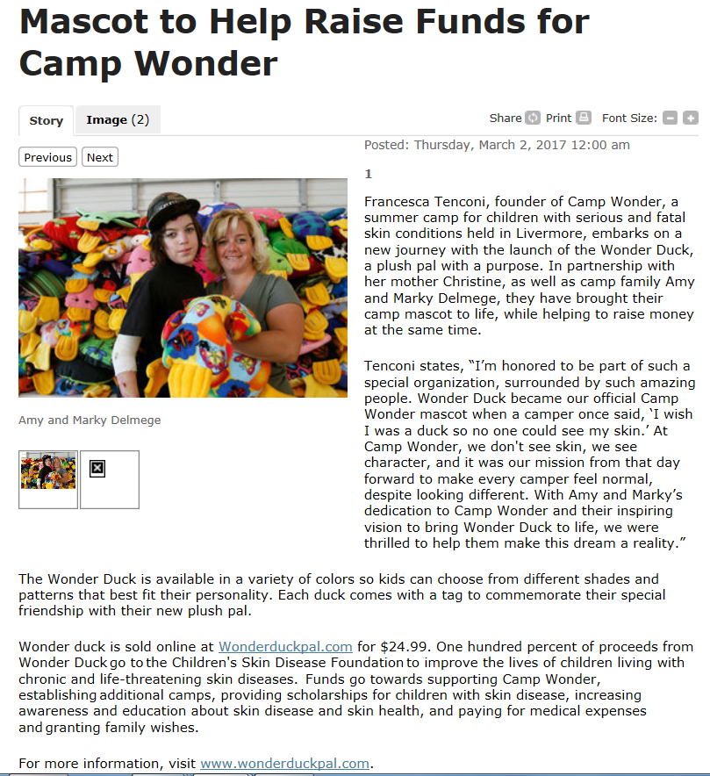

COVERAGE OVERVIEW: “Mascot to Help Raise Funds for Camp Wonder. Francesca Tenconi, founder of Camp Wonder, a summer camp for children with serious and fatal skin conditions held in Livermore, embarks on a new journey with the launch of the Wonder Duck, a plush pal with a purpose. In partnership with her mother Christine, as well as camp family Amy and Marky Delmege, they have brought their camp mascot to life, while helping to raise money at the same time.
Tenconi states, “I’m honored to be part of such a special organization, surrounded by such amazing people. Wonder Duck became
The Wonder Duck is available in a variety of colors so kids can choose from different shades and patterns that best fit their personality. Each duck comes with a tag to commemorate their special friendship with their new plush pal.
Wonder duck is sold online at Wonderduckpal.com for $24.99. One hundred percent of proceeds from Wonder Duck go to the Children's Skin Disease Foundation to improve the lives of children living with chronic and life-threatening skin diseases. Funds go towards supporting Camp Wonder, establishing additional camps, providing scholarships for children with skin disease, increasing awareness and education about skin disease and skin health, and paying for medical expenses and granting family wishes.
For more information, visit www.wonderduckpal.com.”

